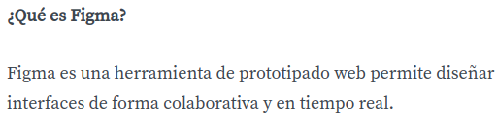

https://www.figma.com/file/gBbiaKFQBeQ8tENigUuh0l/Alura-Latam-Arquitectura-CSS?type=design&node-id=0-1&mode=design&t=9QK6JgiisYKEZhTg-0
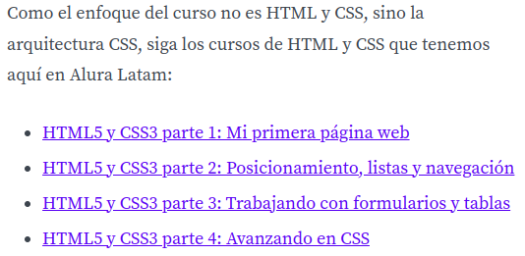

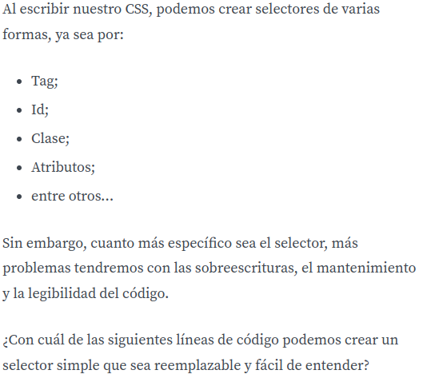

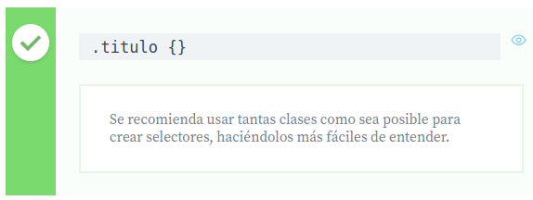

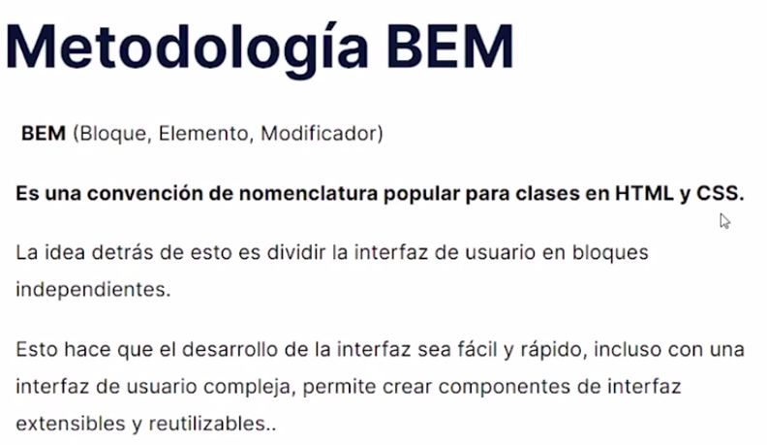

https://en.bem.info/methodology/

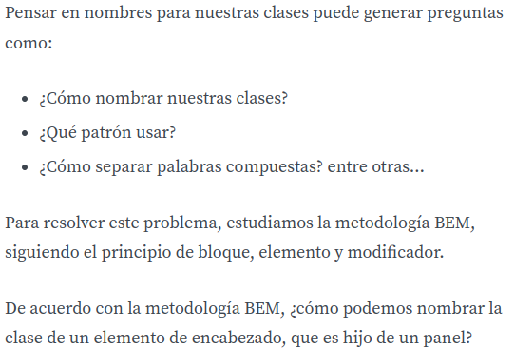

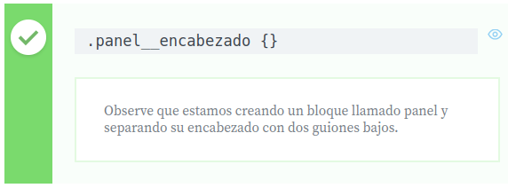

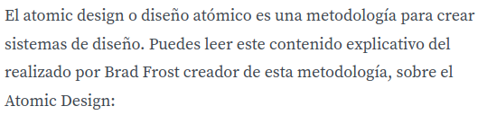
https://bradfrost.com/blog/post/atomic-web-design/

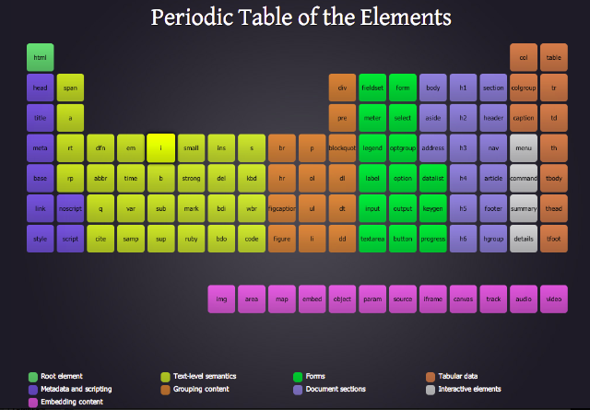
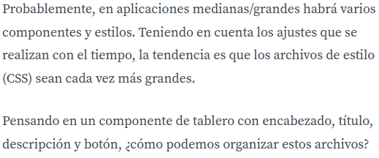

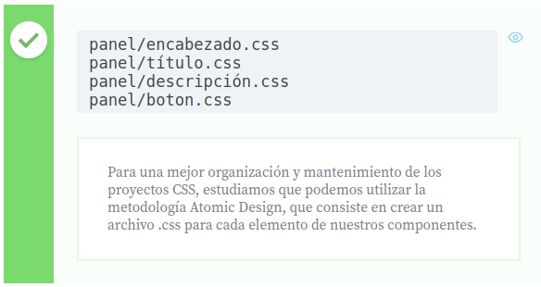

https://developer.mozilla.org/es/docs/Web/CSS/flex-wrap

https://www.aluracursos.com/blog/flexbox-css-guia-completo-elementos-y-ejemplos

https://developer.mozilla.org/es/docs/Web/CSS/Shorthand_properties
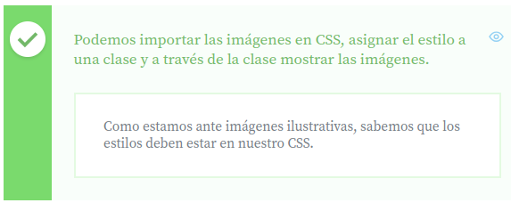
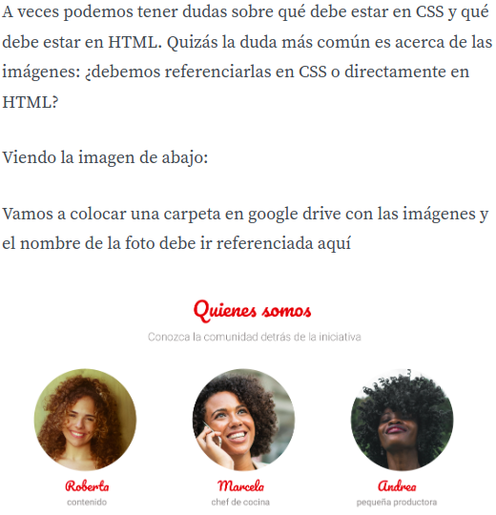

Dónde podemos importar y referenciar nuestras imágenes?
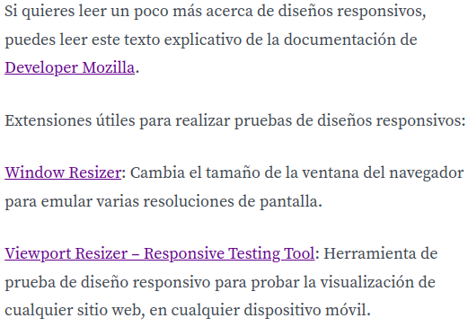

ttps://developer.mozilla.org/es/docs/hLearn/CSS/CSS_layout/Responsive_Design

https://chrome.google.com/webstore/detail/window-resizer/kkelicaakdanhinjdeammmilcgefonfh?hl=es-419Link

https://chrome.google.com/webstore/detail/viewport-resizer-%E2%80%93-respon/kapnjjcfcncngkadhpmijlkblpibdcgm?hl=es-419

https://www.figma.com/file/gBbiaKFQBeQ8tENigUuh0l/Alura-Latam-Arquitectura-CSS?type=design&node-id=0-1&mode=design&t=Orx5WxZ67usxtvUo-0

https://www.aluracursos.com/blog/creacion-de-componentes-css-con-el-estandar-bem

